Welcome to A level Business
We are looking forward to teaching you in September and hope that you are excited too. We have put together some things that you can read/watch or listen to as a preparation for your A level studies (see below). At the end there is also some research we would like you to do, this should be done over several weeks and we will want to discuss it in September with you. We hope you enjoy doing this, keep a record of what you watch/read it will be useful later in your sixth form career. If you have any questions please let me know.

Mrs Styles m.styles@holt.wokingham.sch.uk
Dr Barwah m.barwah@holt.wokingham.sch.uk

Book Recommendations
It is vital that you are accustomed to completing wider reading around topics you will cover during your A levels. As a starting point, we recommend the following titles:
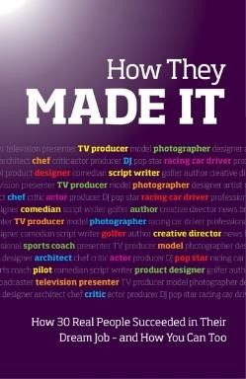

How They Made It

Inspirational stories of how others succeeded in their dream job and how you can too
By: Lucy Smith, Jessica Spencer
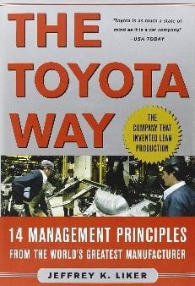
The Toyota Way: 14 Management
Principles from the World's Greatest Manufacturer

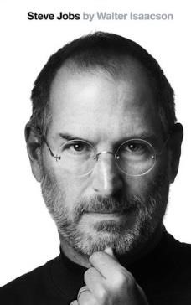

Steve Jobs: The Exclusive Biography

Film/ Documentary Recommendations
There are a number of useful films and documentaries that will develop your wider understanding of the topics covered.
- The Big Short – about the prediction of the financial crisis through identifying the toxic bonds being sold

- Experience never gets old - 70-year-old widower Ben Whittaker has discovered that retirement isn't all it's cracked up to be. Seizing an opportunity to get back in the game, he becomes a senior intern at an online fashion site, founded and run by Jules Ostin.

- Steve Jobs - takes us behind the scenes of the digital revolution, to paint a portrait of the man at its epicenter. The story unfolds backstage at three iconic product launches, ending in 1998 with the unveiling of the iMac.

- The Social Network is a 2010 American biographical drama film directed by David Fincher and written by Aaron Sorkin. Adapted from Ben Mezrich's 2009 book The Accidental Billionaires, it portrays the founding of social networking website Facebook and the resulting lawsuits.

- Up in the Air is a 2009 American comedy-drama film directed by Jason Reitman and written by Reitman and Sheldon Turner, based on the 2001 novel of the same name by Walter Kirn. The story is centered on corporate "downsizer" Ryan Bingham (George Clooney) and his travels.

- Wall Street is a 1987 American drama film, directed and co-written by Oliver Stone, which stars Michael Douglas, Charlie Sheen, and Daryl Hannah. The film tells the story of Bud Fox (Sheen), a young stockbroker who becomes involved with Gordon Gekko (Douglas), a wealthy, unscrupulous corporate raider.

- Rogue Trader is a 1999 British biographical drama film written and directed by James Dearden and starring Ewan McGregor and Anna Friel. The film centers in the life of former derivatives broker Nick Leeson and the 1995 collapse of Barings Bank.
TED talks:
https://www.ted.com/playlists/696/interview_with_a_business_mogul (there are several you can choose from)

Other programmes: Undercover Boss and there seem to be some Mary Queen of shops on youtube. I have also made a folder on n drive (business shared) called DVD downloads and in that there are 3 episodes of a programme called inside John Lewis. It’s a few years old but there is a lot of business in it.

Or to listen to:

https://podcasts.apple.com/us/podcast/business-as-usual/id1451416612 - there are loads and they get updated regularly.

Research Activity

Find out :
- Three businesses have suffered during the coronavirus. Who are they (what do they do), why have they suffered, what is the likely long-term impact?

- Three businesses that have done well during the coronavirus. Who are they (what do they do), why have they benefitted and is this likely to continue into the future?

- Below are several links to news articles about Center Parcs’ in the UK. They cover a number of different areas and aim to give you a broad view of the successes and challenges within the business. You are to investigate all the links and, through further curiosity and perseverance, conduct some of your own research. Find out why is it has been a successful business and what challenges it faces in the future. This should include, but is not limited to, analysis on:
- Center Parcs’ business strategy and objectives
- External factors that influence Center Parcs’ performance
- Centre Parcs’ human resource strategy
- Financial analysis on the revenue and profitability of Centre Parcs’
- Corporate Social Responsibility policy of Centre Parcs’ and evidence of this in practice

Make a note of your findings and keep it for September.

http://www.centerparcs.co.uk/images/pdfs/annual_review_2015.pdf
http://www.telegraph.co.uk/finance/newsbysector/retailandconsumer/leisure/10006670/CenterParcs-plots-Ireland-growth-and-new-jobs-push.html
http://www.citmagazine.com/article/1307391/innocent-ryman-events-boost-center-parcsgrowth
http://www.nottinghampost.com/s-like-work-Center-Parcs/story-29171859-detail/story.html http://www.bbc.co.uk/news/uk-27113093 http://www.centerparcs.co.uk/activity_pricing
http://www.theguardian.com/travel/2015/apr/14/top-10-family-friendly-holidays-ukalternatives-center-parcs
http://www.telegraph.co.uk/finance/newsbysector/retailandconsumer/leisure/9115370/CenterParcs-pumps-250m-into-fifth-UK-site.html https://prezi.com/fe3llfp6vbcd/center-parcs/
https://www.gov.uk/government/uploads/system/uploads/attachment_data/file/48532/3434centre-parcs-crc-case-study.pdf
http://www.triggerfish.co.uk/press-release/center-parcs-completes-hat-trick-of-refurbishmentsover-the-last-year/
http://www.butlins.com/events/why-butlins/news/news-promotion/shoreline-hotelrefurbishment.aspx
http://www.evoenergy.co.uk/case-studies/center-parcs/

Finally keep up to date with what is happening in the business world by setting the business page of the BBC website as your homepage and read or watch the news every day.

Social Media and Websites
A who’s who of who to follow on social media…..
You need to be aware of current global events that are related to the units you will be studying; so look out for things in the news to do with the topics we are studying. You can use Google Alerts to make this easier
http://www.google.co.uk/alerts?hl=en

There are also many good websites you can use.
www.tutor2u.net http://www.bbc.co.uk/news/ https://www.ons.gov.uk/economy http://www.theguardian.com/data
http://www.economist.com/

Also look at the tutor2u youtube channel and try this website for revision http://www.scool.co.uk/

