KS5

Further

Mathematics induction booklet.

Remember to read the Mathematics booklet too.

You need to complete that work and buy those text books too.

KS5 Maths Coordinator: Mr Green [r.green@holt.wokingham.sch.uk](mailto:r.green@holt.wokingham.sch.uk)

Further Mathematics Textbooks

Further Mathematics Textbooks

These are the textbooks you need for the course, The Stats and Decision will last for AS and A2, you will need to buy Core book 2 in year 13

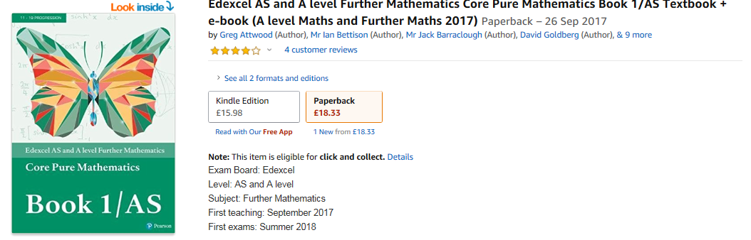

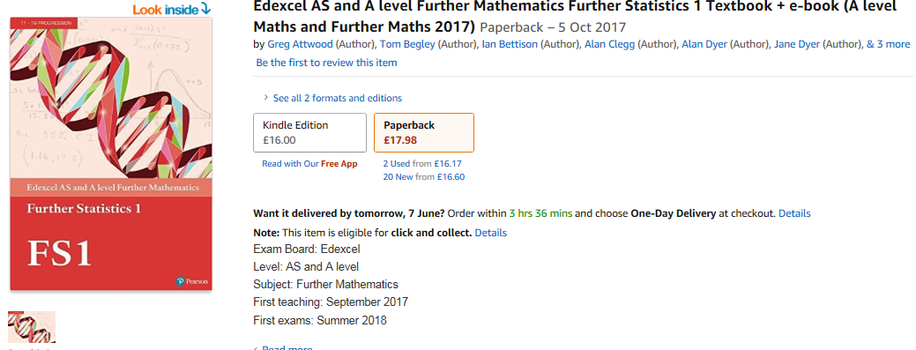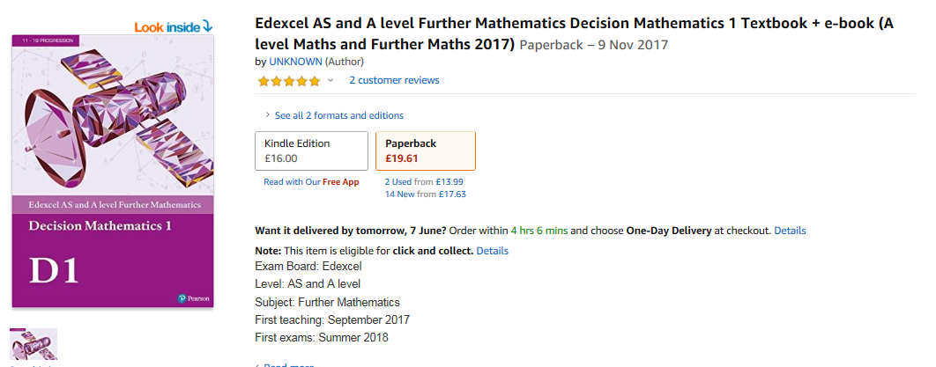

Induction Topic 1: Measuring Angle in Radians.

The fact that there are 90 degrees in a right angle will have been familiar to you since primary school, but this number is an arbitrary one which has been passed down to us from the Babylonian civilisation. There was an attempt to introduce 100 degrees in a right angle soon after the French revolution, but this was later dropped and in 1983 a similar attempt was made by the Germans.

But degrees are not the only way to measure angles. The other common measurement for angles is radians, which is much more useful for many applications in mathematics.

If we consider a circle of radius r then the arc length r will subtend an angle of 1 radian at the centre. This means that:

And so

|  |  |
| --- | --- |
| degrees | Radians |
| 30° | π/6 |
| 45° | π/4 |
| 60° | π/3 |

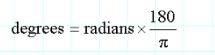

To convert radians to degrees:

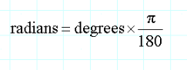

To convert degrees to radians:

Examples to try:

1. Convert to radians giving your answers to 2 decimal places

|  |  |  |  |  |  |
| --- | --- | --- | --- | --- | --- |
| **Angle in degrees** | 17 | 51 | 243 | - 131 | - 596 |
| **Angle in radians** |  |  |  |  |  |

2. Convert to radians giving your answer in term of 

|  |  |  |  |  |  |
| --- | --- | --- | --- | --- | --- |
| **Angle in degrees** | 360 | 315 | - 300 | - 630 | 18 |
| **Angle in radians** |  |  |  |  |  |

3. Convert to degrees giving an exact answer

|  |  |  |  |  |  |
| --- | --- | --- | --- | --- | --- |
| **Angle in degrees** |  |  |  |  |  |
| **Angle in radians** |  |  |  |  |  |

4. Convert to degrees giving your answer to one decimal place

|  |  |  |  |  |  |
| --- | --- | --- | --- | --- | --- |
| **Angle in degrees** |  |  |  |  |  |
| **Angle in radians** | 0.76 | - 1.13 | - 11.38 | 6.42 | - 0.032 |

**Degrees and Radians: Solutions**

1. Convert to radians giving your answers to 2 decimal places

|  |  |  |  |  |  |
| --- | --- | --- | --- | --- | --- |
| **Angle in degrees** | 17 | 51 | 243 | - 131 | - 596 |
| **Angle in radians** | 0.30 | 0.89 | 4.24 | - 2.29 | - 10.40 |

2. Convert to radians giving your answer in term of 

|  |  |  |  |  |  |
| --- | --- | --- | --- | --- | --- |
| **Angle in degrees** | 360 | 315 | - 300 | - 630 | 18 |
| **Angle in radians** |  |  |  |  |  |

3. Convert to degrees giving an exact answer

|  |  |  |  |  |  |
| --- | --- | --- | --- | --- | --- |
| **Angle in degrees** | 135 | - 210 | 72 | - 27 | 495 |
| **Angle in radians** |  |  |  |  |  |

4. Convert to degrees giving your answer to one decimal place

|  |  |  |  |  |  |
| --- | --- | --- | --- | --- | --- |
| **Angle in degrees** | 43.5 | - 64.7 | - 652.0 | 367.8 | - 1.83 |
| **Angle in radians** | 0.76 | - 1.13 | - 11.38 | 6.42 | - 0.032 |

Induction topic 2: Matrices

A Matrix is a rectangular array of numbers arranged in rows and columns.

The individual numbers in a matrix are called elements.

The order of dimensions of a matrix describes the matrix in terms of the number and rows and columns it has.



Eg has 2 rows and 3 columns so has order 2 x 3

**Addition and subtraction of matrices:**

Matrices of the same order can be added or subtracted by adding or subtracting the corresponding elements.

**Multiplication of a matrix by a number:**

Each element of a matrix is multiplied by the multiplying number.

**Multiplication of two matrices:**

Matrices can be multiplied only if they are compatible. The number of columns in the left hand matrix must be the same as the number of rows in the right hand matrix.

*You may find it useful to do an internet search for you tube clips that demonstrate matrix operations.*

Questions to try:

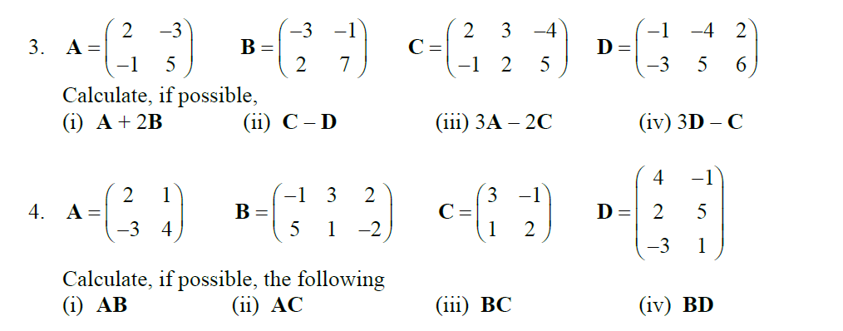

Answers

