**PE Transition Work**



Hello all our budding new A level PE students – we are super excited to be teaching you next year. We are biased but it truly is a great course to do at The Holt School.

Task 1:

30% of the content for A Level PE is Applied Anatomy and Physiology, Exercise Physiology and Biomechanics. There is quite a bit of content in these sections but some of it does relate to GCSE PE which is fantastic. It was extremely helpful to us when they changed GCSE PE to include more science as now it isn’t such an enormous step up for content as it once was. However, saying this, we need to be on the best footing moving into A Level PE so you must be really confident with the content of paper 1 from GCSE PE.

There are links to both the GCSE PE and A level PE specifications below - we would like you to get a highlighter and compare the two specifications for sections named above. Pick one colour and highlight the content which is the same or very similar (obviously A level will have more content or more advanced content but the GCSE content forms a basis for this). It is your decision whether you print it or use a highlighter tool on a computer. We would then like you to review your GCSE revision notes you made for these particular highlighted sections.

When you come into the lessons in year 12 we expect you to know this GCSE content inside and out, we don’t have time to cover this again, only build upon it. These sections are fantastic so we would love for us all to enjoy it together!

GCSE PE link (page 7-15 needed): <https://qualifications.pearson.com/content/dam/pdf/GCSE/Physical%20Education/2016/Specification%20and%20sample%20assessments/GCSE-physical-education-2016-specification.pdf>

A Level PE link (page 5-20 needed):

<https://www.ocr.org.uk/Images/234833-specification-accredited-a-level-gce-physical-education-h555.pdf>

An example of what we mean:

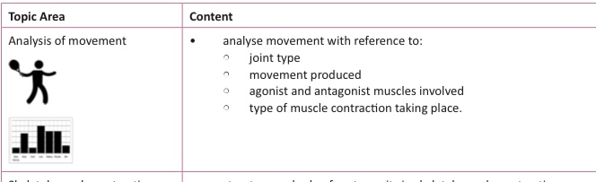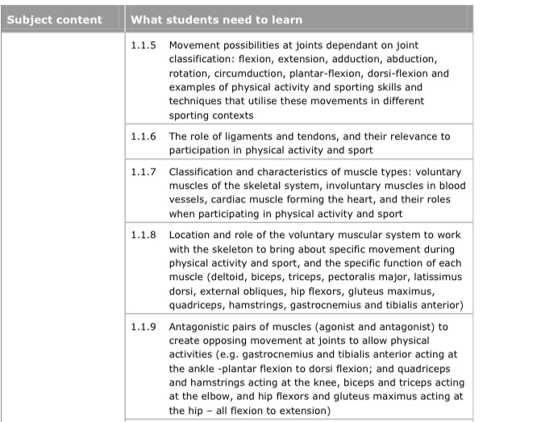

Each of these are from different specifications but you can clearly see that you need to know joint types for each specification, movement produced at the joints and agonist/antagonist muscles. This then can all be highlighted. We haven’t, however, matched type of muscle contraction so we do not have to highlight it.

Task 4: Print and complete pages 1-16 of the following: [1.1.a-Pupil-Booklet-Skeletal-and-Muscular-systems.pdf (thepeclassroom.com)](https://thepeclassroom.com/wp-content/uploads/securepdfs/2022/08/1.1.a-Pupil-Booklet-Skeletal-and-Muscular-systems.pdf)

Task 3: Produce a log of your competitive sports in 2022. This may include a record of fixtures, matches or competitions. Also include video footage or pictures of you in action.

Task 4: Use social media to follow BBC Sport. Screenshot any interesting stories between now and September ready for discussion when you start your course.

Resources for the course:

A-level PE textbook: Powell and Honeybourne, OCR level PE (Year 1 and Year 2). 2019.

**Please contact Mrs Bolton** [**s.bolton@holt.wokingham.sch.uk**](mailto:s.bolton@holt.wokingham.sch.uk) **or Mrs Ebden** [**g.ebden@holt.wokingham.sch.uk**](mailto:g.ebden@holt.wokingham.sch.uk) **if you have any queries.**