Welcome to A-level physics at the Holt School.

Congratulations on picking one of the most interesting A-level subject options. I cannot promise you things will always be easy, but they will definitely be rewarding.

A level physics is the one of the steps needed for you to become a world changing scientist, or simply help you understand how the world works. Physics will challenge you to make links and ask more questions. It provides a foundation of knowledge for you to start to answer questions for yourself and for you to make informed choices about your future.

The information in this pack is designed to bring everyone to the same point in their knowledge. No one should feel that are starting this course at a disadvantage, because for example, they did combined science instead of triple. The research tasks I have suggested come with a justification of why you might it useful and the pre-course tasks are made up of activities that students have suggested are beneficial in the past.

Hopefully you will find the information enclosed valuable and tasks interesting. If you have any problems or questions please contact me via email (m.lewis@holt.wokingham.sch.uk).

I look forward to seeing you in September,
Dr M K Lewis
Head of Physics
Book Recommendations
It is vital that you are accustomed to completing wider reading around topics you will cover during your A levels. As a starting point, we recommend the following titles:
(remember, you can add these to your wider reading log in September!)
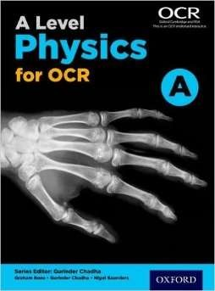 | A Level Physics for OCR  Graham Bone, Gurinder Chadha, Nigel Saunders  ISBN-10: 0198352182  This is the course textbook. If you only buy one book on this list it should be this one. We will sometimes refer to it in lessons, and should be brought with you!  ***This book is on Kerboodle, but having a physical copy does help***
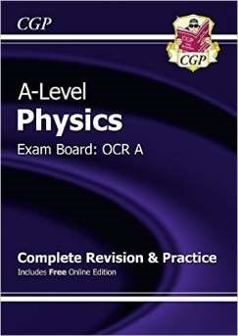 | New A-Level Physics: OCR A Year 1 & 2 Complete Revision & Practice  CGP Books  ISBN-10: 1782943064  It is always helpful to have a study guide and it is far cheaper than a tutor. If you found the GCSE version helpful this book would be a good addition to your library.
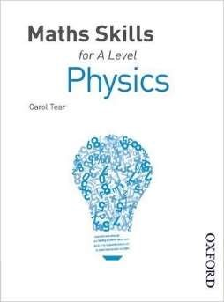 | Maths Skills for A Level Physics  Carol Tear  ISBN-10: 1408521202  Mathematics is the language of physics. Up to 40% of the exam involves math skills of some description. We will cover all of the required maths to understand the course, but this book will help you practise if you find maths difficult.  ***If you are NOT taking A-level Mathematics, then I would strongly advise you to get this book***
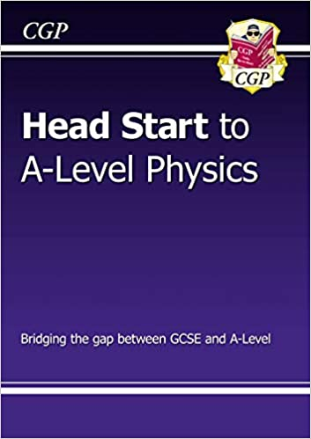 | Head Start to A-level Physics  CGP Books  ISBN-10: 1782942815  During your GCSE you may have done triple science or combined science, this may have been on the OCR, AQA or some other exam board. This book contains a series of information and exercises to make sure that everyone starts the course with approximately the same knowledge. It will also help you spot any areas of the GCSE that you didn’t understand.

Film/ Documentary Recommendations
There are a number of useful films and documentaries that will develop your wider understanding of the subject or just illustrate how the subject is misused – you decide. Whichever category, all these films are essential viewing for any film lover.
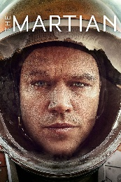 | When astronauts blast off from the planet Mars, they leave behind Mark Watney (Matt Damon), presumed dead after a fierce storm. With only a meagre amount of supplies, the stranded visitor must utilize his wits and spirit to find a way to survive on the hostile planet. Meanwhile, back on Earth, members of NASA and a team of international scientists work tirelessly to bring him home, while his crew mates hatch their own plan for a daring rescue mission.
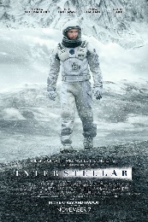 | In Earth's future, a global crop blight and second Dust Bowl are slowly rendering the planet uninhabitable. Professor Brand (Michael Caine), a brilliant NASA physicist, is working on plans to save mankind by transporting Earth's population to a new home via a wormhole. But first, Brand must send former NASA pilot Cooper (Matthew McConaughey) and a team of researchers through the wormhole and across the galaxy to find out which of three planets could be mankind's new home.
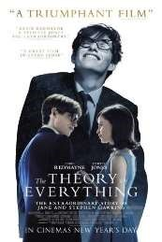 | The Theory of Everything is the extraordinary and uplifting story of one of the world’s greatest living minds, the renowned astrophysicist Stephen Hawking, and of two people defying the steepest of odds through love. The film, based on the memoir Travelling to Infinity: My Life with Stephen, by Jane Hawking, is directed by Academy Award winner James Marsh (Man on Wire).
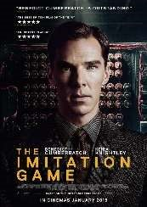 | The Imitation Game is a gripping, acclaimed thriller that tells the incredible true story of unsung war hero Alan Turing, the British mathematician responsible for cracking the German Enigma code during World War II. Benedict Cumberbatch (The Fifth Estate, Star Trek Into Darkness, and TV’s Sherlock) and Keira Knightley (BAFTA nominee for Atonement, Oscar nominee for Pride and Prejudice) star as Turing and his ally and fellow code-breaker Joan Clarke.
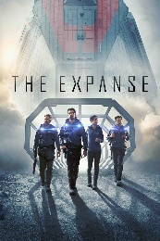 | Hundreds of years in the future, things are different than what we are used to after humans have colonized the solar system and Mars has become an independent military power. Rising tensions between Earth and Mars have put them on the brink of war. Against this backdrop, a hardened detective and a rogue ship's captain come together to investigate the case of a missing young woman. The investigation leads them on a race across the solar system that could expose the greatest conspiracy in human history.

Research Activity
Using the internet and books, complete the following task. You should produce notes using the Cornell Note Taking System (http://lsc.cornell.edu/wp-content/uploads/2015/10/Cornell-
Note_Taking-System.pdf) on the following topic(s). Make sure you have your notes with you for your first lesson in September.
- Very few people choose A-level physics because they are interested in errors or mechanics! The first research task is something to keep you going when things seem tough. Pick any area of physics that you find interesting, maybe it is something you know nothing about. Maybe you want to do a degree in astronomy. Maybe you want to be a particle physicist. Research that area of physics in as much depth as you like and try and summarise it for me. The point in this is to:
  - Provide you with some light at the end of the tunnel. This is what you are aiming for.
  - Allow me to know what people in the class are aiming for, if you are interested quantum physics then I will include more of this during our in class discussions.
  - It is practise for a PAG task that is required in year 13.
  - You will get a lot of information in this course, and need to be able to pick out and summarise the key points.

- Pick a topic from the A-level textbook (this is on Kerboodle if you can’t get a physical copy), read through and make a revision product that includes the key points on no more than a piece of A4. You should pick something from module 3 or 4 which we cover in the first year for this task. The reason for this task is:
  - At some point you may need to learn something for yourself! If you are going to struggle with a task like this, it is better to find out sooner rather than later.
  - There are approximately 700 pages in the textbook, you will not be able to remember them all. Picking out the key information to learn is a key skill.
  - When we cover this topic in class, you will be able to see yourself making progress. You will be able to see what you thought was important then, and what is important now.

***Place both of these items in your folder (see below), you will look back on them eventually.***

Pre-Knowledge Task
Please ensure you complete the following task in preparation for your September start. Your teacher will ask to see it.
- Get a folder and get organised early. You may wish to get two eventually one for year 1, and one for year 2. In the folder you will have 6 modules, split into 27 sub-topics. In each sub-topic will have a 4 to 9 lessons, and in these lessons you will have a mixture or notes, question practise, homework, exam questions, revision products, and tests. If you just throw everything into your bag or locker you are going to end up in a pickle very quickly.

- Print out the specification and A-level formula sheet. Then put them in your folder! They are a good reference, that you may never have used at GCSE. At A-level they are specific about what you need to know, and how topics can link together.

- Go through the “Headstart to A-level physics book” answering the questions inside. If you cannot answer any of the questions, or you find a particular topic difficult make a note. I will ask to see these notes in the first lesson so I have a good idea of what people already find difficult.

- Make yourself a crib sheet or poster of A4/A5 size with the prefixes and their symbols. We will use these often and you will need to know them at some point. Having a sheet with them on will help you during the early course.

- Make yourself a crib sheet or poster of A4/A5 size with the Systeme Internationale (S.I.) base quantities and their units. We will very early on need to express things like Newtons and Pascals in their base units. Knowing what the base units are will help immensely.

Ideas for Day Trips
Visiting some of the places in the list below could be fun AND educational….
London Science Museum (http://www.sciencemuseum.org.uk/)
Royal Greenwich Observatory (http://www.rmg.co.uk/royal-observatory)
Brooklands Museum (http://www.brooklandsmuseum.com/)
Bletchley Park (https://www.bletchleypark.org.uk/)
Imperial War Museum – Duxford (http://www.iwm.org.uk/visits/iwm-duxford)

Book in Advance:
Rutherford Appleton Laboratory (http://www.stfc.ac.uk/public-engagement/see-the-science/visit-us-at-ral/) Dungeness B Nuclear Plant (https://www.edfenergy.com/energy/education/visitor-centres)

Social Media and Websites
A who’s who of who to follow on social media…
You probably know more about social media than I do at the moment. If you have any suggestions let me know!

