**Spanish A-Level at The Holt School**



¡Bienvenidos! Welcome ….to Spanish A-Level at The Holt School. We are really looking forward to starting your post-16 studies of Spanish with you. Soon you will realise that everything I said at the open evening was true, studying a language at A-Level really is like studying a wide range of different subjects all at the same time as we explore history, culture, geography, sociology, literature, film, politics and many more areas of study together. The aim of the transition work is to open your eyes to different facets of Hispanic culture and to encourage you to explore the areas that interest you or that you don’t know much about yet. Later in the A-Level course you will have the opportunity to select a topic of your choice to investigate in depth ready for your IRP (Independent Research Project) which will form the basis of your speaking assessment. Hopefully the tasks below will inspire you to start your investigation now so that you can begin to establish your preferences for later on, you might be surprised what sparks your interest as you try different activities out!

Saludos,

Señora Ellison, Señora Totolan-Moore y Señora Diaz

[a.ellison@holt.wokingham.sch.uk](mailto:a.ellison@holt.wokingham.sch.uk)

[lto@holt.wokingham.sch.uk](mailto:lto@holt.wokingham.sch.uk)

dz@holt.wokingham.sch.uk

**Transition work suggestions**

**Música:** Why not listen to a new Hispanic artist, discover a new song by an artist you know well or take a deeper look at the lyrics or story behind some of their songs?

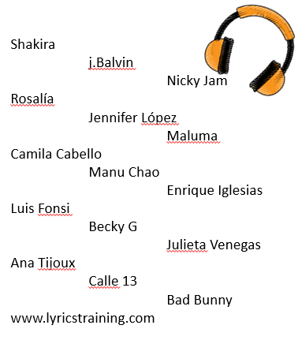

**La television y las películas:** Films and TV programs are an excellent way to practice your listening skills, learn about Hispanic culture and history and learn vocabulary that might not come up in the textbook!

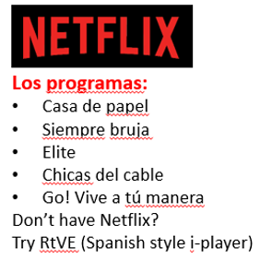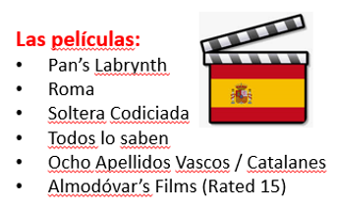

**El vocabulario y la gramática:** It is essential that you keep practicing your grammar and learning new vocabulary between now and the start of the course in September so that you are ready to hit the ground running!

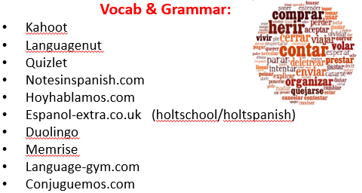

**Los temas de la actualidad:** A lot of the topics that come up in the course come from current affairs and it is useful to stay on top of what is happening right now in the Hispanic world. If you get into a habit of reading about it now it will inform your opinions as we start to discuss and debate the topics in more depth.

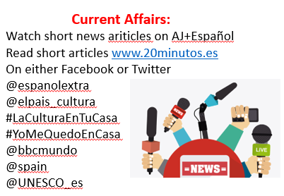

**La investigación:** When you come across something that interests you in your reading of current affairs then you could start to do some wider research to deepen your understanding of the issue or topic. Here are some ideas to get you started.

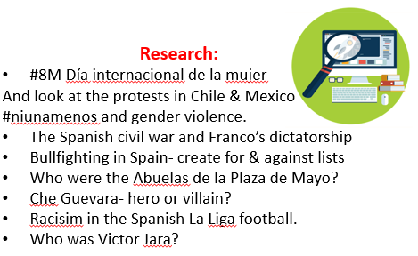

**Ser creativo:** Learning isn’t all about reading, watching and listening. Often we learn the most when we ‘do’. Here are some ideas of things to get those creative and practical juices flowing (but don’t feel restricted by these suggestions!).

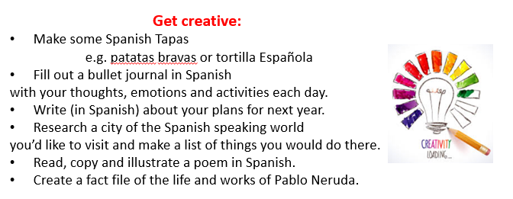

**Practicalities:**

**By September you will need to have purchased (either new or second hand)-**

1. **A-Level Year 1 AQA Spanish student textbook ISBN: 978-0-19-836690-4**
2. **A large ringbinder with 17 dividers.**

**You might also find the following useful-**

* A copy of- the book **‘***La Casa de Bernarda Alba* by Lorca in Spanish and in English and the film ‘*Ocho Apellidos Vascos’* which we will be studying later in the course.
* **Palabra por Palabra Fifth Edition Vocabulary Book ISBN: 978-1-4441-1001-2**
* **AQA Spanish AS Grammar Workbook ISBN: 978-1-4085-2013-0**
* [A-level Spanish Writing Skills: Essays, Translations and Summaries: For AQA, Pearson Edexcel and Eduqas: Amazon.co.uk: Thacker, Mike, Bianchi, Sebastian: 9781398311985: Books](https://www.amazon.co.uk/level-Spanish-Writing-Skills-Translations/dp/1398311987/ref=asc_df_1398311987/?tag=googshopuk-21&linkCode=df0&hvadid=463063581070&hvpos=&hvnetw=g&hvrand=12430931920524563097&hvpone=&hvptwo=&hvqmt=&hvdev=c&hvdvcmdl=&hvlocint=&hvlocphy=1007247&hvtargid=pla-1030401855016&psc=1&mcid=dfe40c72a0563e24ba2e6eaa91370475&th=1&psc=1)
* A bi-lingual Collins Spanish-English Dictionary (although most students use [www.wordreference.com](http://www.wordreference.com) or [www.spanishdict.com](http://www.spanishdict.com))